**Raspberry Pi Setup**

**Operating System Installation**

Debian Jessie

# Items Needed:

* Raspberry Pi 3 Model B ($36.79) <https://amzn.com/B01CD5VC92>
  + The Pi 3 has onboard WiFi which saves about $12!
  + This guide assumes you have a Pi 3. Much of it may work with a Pi 2, but there are no guarantees.
* 32 GB Micro SD Card (Class 10) – ($9.66) <https://amzn.com/B010Q57T02>
* 5 Volt/2.5 Amp Micro USB Charger ($9.99) <https://amzn.com/B00MARDJZ4>
* You might have these lying around already. These are samples, you don’t need these exact types:
  + USB Keyboard and Mouse ($14.95) <https://amzn.com/B00B7GV802>
  + HDMI Cable ($2.99) <https://amzn.com/B011ESUDKI>
  + HDMI Monitor or TV
  + Windows PC with SD Card Reader
    - If your PC doesn’t have a card reader, you need something like this: <https://amzn.com/B009D79VH4>

# Preparing the SD Card:

* I always prefer to start with a freshly formatted SD card. The SD Association has free software for this. Download and install the SD Card formatter.
  + <https://www.sdcard.org/downloads/formatter_4/>
* Once it is installed, insert your Micro SD card into your reader (you may need a Micro adapter) as shown here:

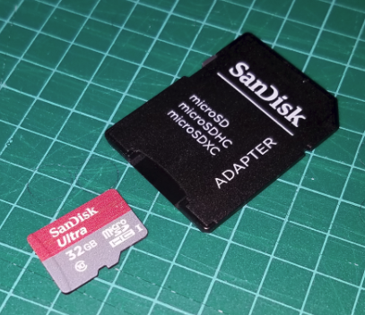

* Launch the SDFormatter, click on “Option” and select Format Type: Full (OverWrite) and Format Size Adjustment: On. Click Okay.

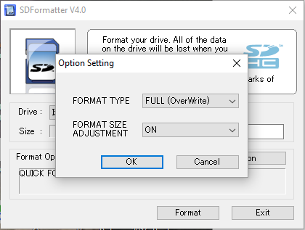

* After ensuring the Drive is set to your SD Card (Mine was mapped to I:), you can enter a new name in the Volume Label if you desire, and then click on Format to begin. On my computer, a 32 GB card took 35 minutes to format. You can continue to the next step while this completes.

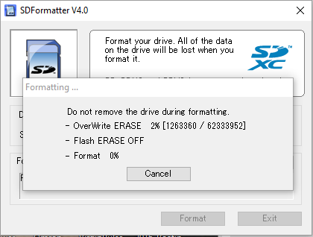

* Once completed you should see a screen like this. Congratulations, this step has successfully completed:

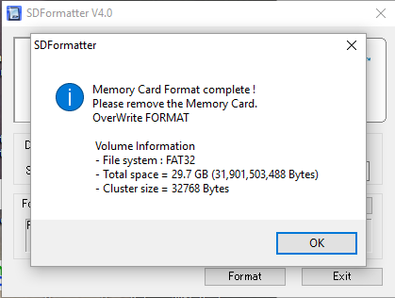

# Downloading and Verifying the Latest Raspberry Pi Operating System:

* I recommend downloading the latest release of NOOBS from the Raspberry Pi organization.
  + <https://www.raspberrypi.org/downloads/noobs/>
  + Download the NOOBS ZIP file and take note of the SHA-1 hash code.
  + As of July 1, 2016 this is what the link and hash look like. Unless you happen to get the exact same version, the SHA-1 hash code will be different, so this is shown only as a sample, and you shouldn’t expect this code. Version 1.9.2 was about 1 GB and took about 15 minutes to download.

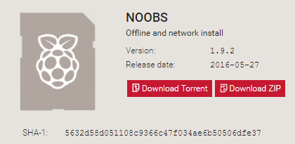

* + While that is downloading, you can download the tool to compute the hash of your downloaded file. The hash is kind of like a fingerprint of the file and by computing the hash on your downloaded file and comparing it with the expected version, you can know for certain that the large download was received successfully. That said, I have downloaded a lot of large images in my career and I have yet to catch an error, so skip this step if you want, but it doesn’t take long and it gives you some piece of mind.
    - Download FCIV.EXE from Microsoft:
      * <https://www.microsoft.com/en-us/download/details.aspx?id=11533>
      * Place this in the same directory as the NOOBS zip file.
    - Once the NOOBS ZIP file is downloaded, open a command window (press the windows key and the letter r at the same time and open “cmd.exe”. Change to the directory of your downloads using the “cd” command and run the following command:
      * fciv.exe –-add *NOOBS…zip* -sha1
        + Note there are two dashes in front of add and change NOOBS…zip to the name of your downloaded file.
      * Once you get the hash result, compare it to the expected value on the NOOBS download page:

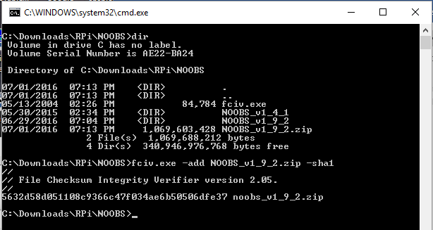

* + Unzip the NOOBS zip file. Once completed, you can delete the zip file if you desire. To unzip, right click on the filename and select Extract All:

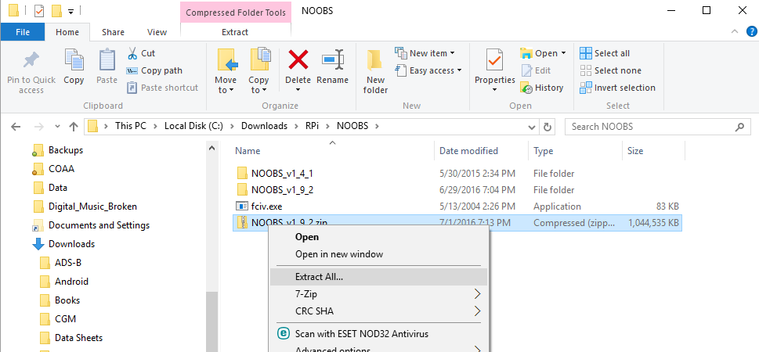

# Loading the OS Files onto the SD Card:

* Once your SD card is formatted and you have unzipped the NOOBS…zip file, you are ready to load the files onto the SD card. Navigate into the NOOBS directory and copy the contents to the SD card. Note, do not simply copy the top level directory (i.e. 1.9.2), you need to copy the contents of that directory to the SD card. Here is what my SD card looks like after copying the files over:

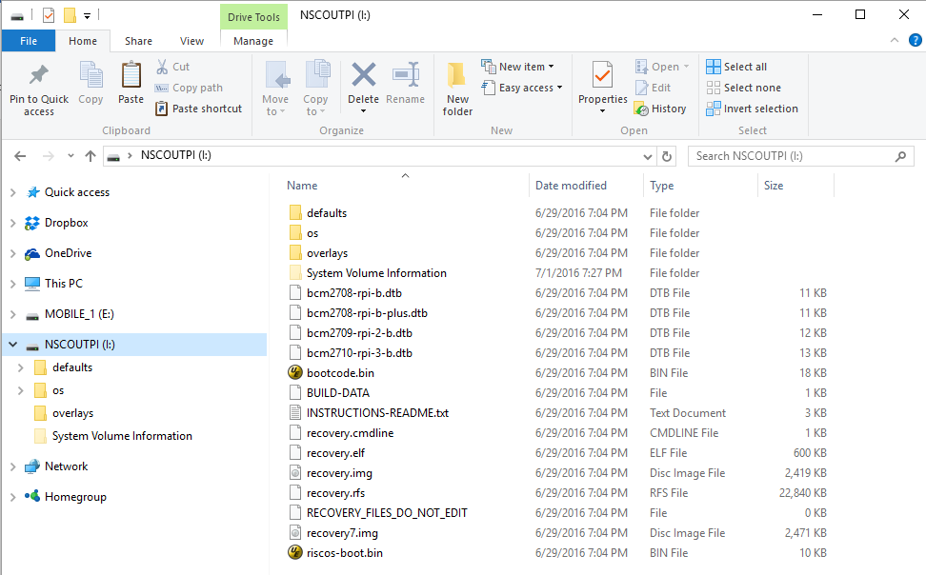

* You are now ready to boot up your Pi and install the operating system

# Debian Installation and Initial Setup:

A note about ESD: Electro Static Discharge can damage sensitive electronics. This damage may cause issues immediately, or it may cause latent defects that will appear later. Because of this, it would be optimal to have a full ESD workstation at home, but of course that probably isn’t practical or likely. There are steps you can take, however, to minimize the chances of an ESD event. Immediately prior to working on any electronics, you should touch the metal chassis of a computer that is connected to power via a 3-prong plug. You should also work with your electronics on top of the shiny ESD bag that electronics are shipped in. By touching the bag and then touching a computer chassis you may help minimize the ESD risks. Doing these steps might be better than nothing, but still a long way from being ESD compliant. If you want to know more (a lot more) about ESD, read through this tutorial: <http://www.radio-electronics.com/info/circuits/esd/what-is-basics-electrostatic-discharge-tutorial.php>.

* Insert the Micro SD card fully into the Pi:

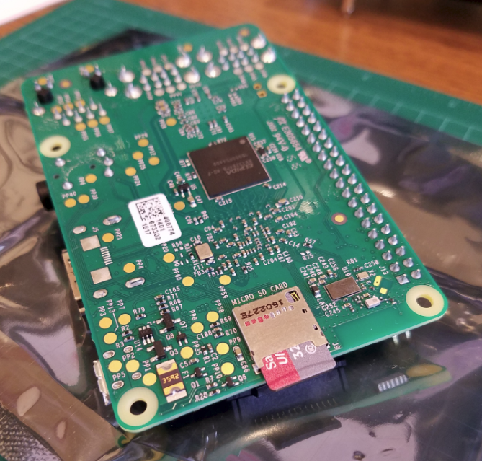

* Connect your keyboard, mouse, and HDMI cable to your TV/Monitor and the Pi. Once those are connected, you can power on the Raspberry Pi by connecting the USB charger:

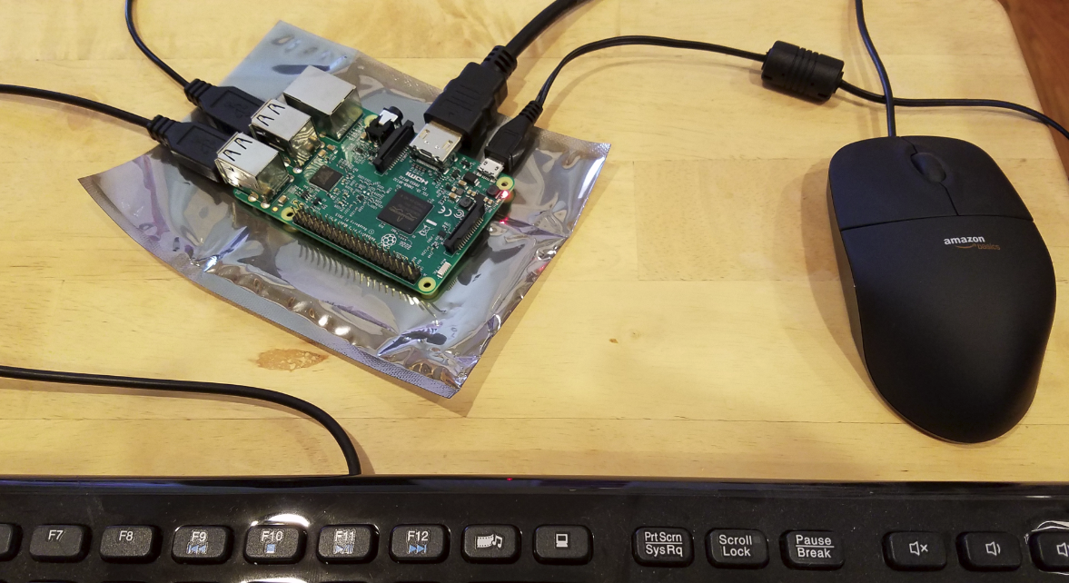

* Your Raspberry Pi will boot and present you with the NOOBS installation screen. Select Raspbian (which is a port of Debian Jessie for the Pi) and select your language and keyboard at the bottom of the screen, then click on “Install” to begin the. Click “Yes” on the confirmation screen and then sit back and relax while Debian is unpacked onto your SD card. When you see the “OS(es) Installed Successfully message box, click “OK” to reboot and continue.

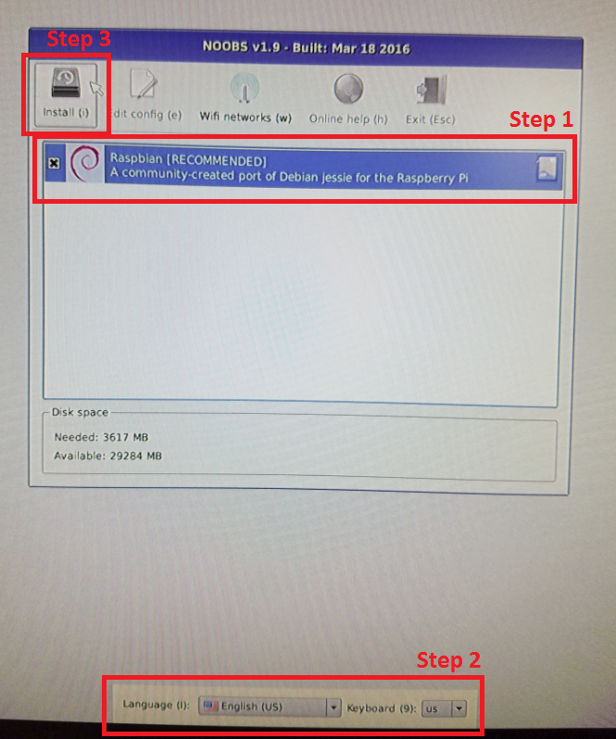

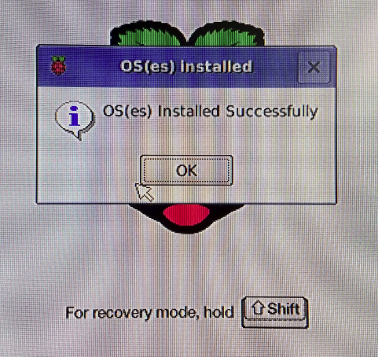

* Your Pi will now boot into X-Windows. The first step is to complete some of the configuration. Click on “Menu”, select “Preferences”, and then “Raspberry Pi Configuration.”
  + “System” Tab:
    - You should set a password for yourself. The username is “pi”, and the current password is “raspberry”, by the way.
    - Change the hostname to whatever you want to call your device.
    - For the time being, leave the “Boot” selection set on “To Desktop” which means X-Windows. If you need to boot to the command line for some reason in the future, you can select “To CLI.”
    - Unless you have security concerns that dictate otherwise, you can leave Auto Login/”Login as user ‘pi’” selected.
  + Interfaces Tab:
    - Depending on what you will be doing with your Pi, you may want to enable some of the interfaces. Generally, you don’t need to enable anything here unless you know you need to do so. SSH is a good one to enable always, however, as it will allow easier remote access via PuTTy if you desire (optional).
      * <http://www.chiark.greenend.org.uk/~sgtatham/putty/download.html>
  + Performance Tab:
    - No changes are necessary
  + Localisation Tab:
    - Locale:
      * Set your language and country, and you can change the character set if needed. For English in the US you will should stick with UTF-8.
    - Timezone:
      * Set your timezone as desired. For my weather station systems, I choose Area: “Etc” and Location: “UTC” to run in Coordinate Universal Time. For most other uses you will probably want local time, which for me is “US” and “Mountain.”
    - Keyboard:
      * The keyboard defaults to UK English...change this to your area…for me it is United States and English (US).
    - WiFi Country:
      * Set your WiFi Country code, “US” for the United States.
  + Click “OK” when complete and reboot your Pi.
* Configure your onboard WiFi to connect to your home network.
  + In the upper right hand corner of the screen, right click on the network icon (two computer screens) and select “WiFi Networks (dhcpcdui) Settings”

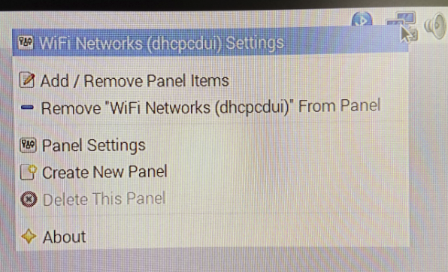

* + In the window that opens, choose to configure “SSID”, and then select your WiFi network.
  + I always assign a static IP addresses, so I uncheck “Automatically configure empty options” and then I fill in the IP address, Router, and DNS Servers. The values shown below are for my network, and yours may well be different. I highly recommend using Static IP as remote access into the Pi will be much easier if you are on a fixed and known IP address.

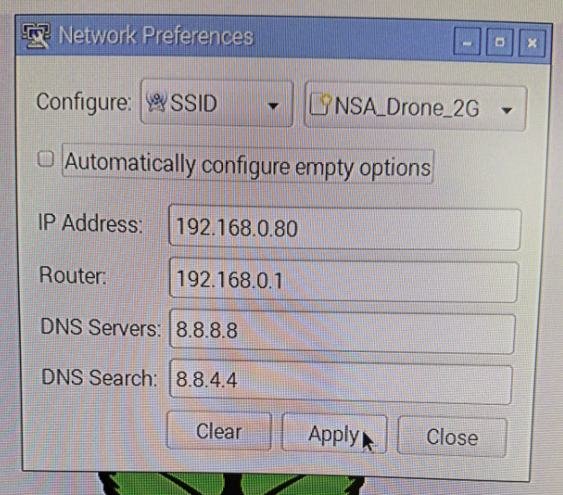

* + Click “Apply” and then “Close”
  + Now left click on the network icon, choose your WiFi network, and enter your Pre Shared Key. Once connected the network icon will change from the two screens to the WiFi symbol.

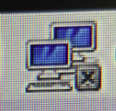 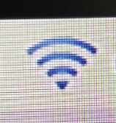

* If you want to check your connectivity, you can open a terminal (monitor icon in the upper left hand corner) to get a command prompt.
  + There is a known bug with the permission settings on ping, so prior to using it run the following command:
    - sudo chmod u+s /bin/ping
  + You can then check your connectivity with ping:
    - ping -c4 www.google.com
    - you should get results like this:

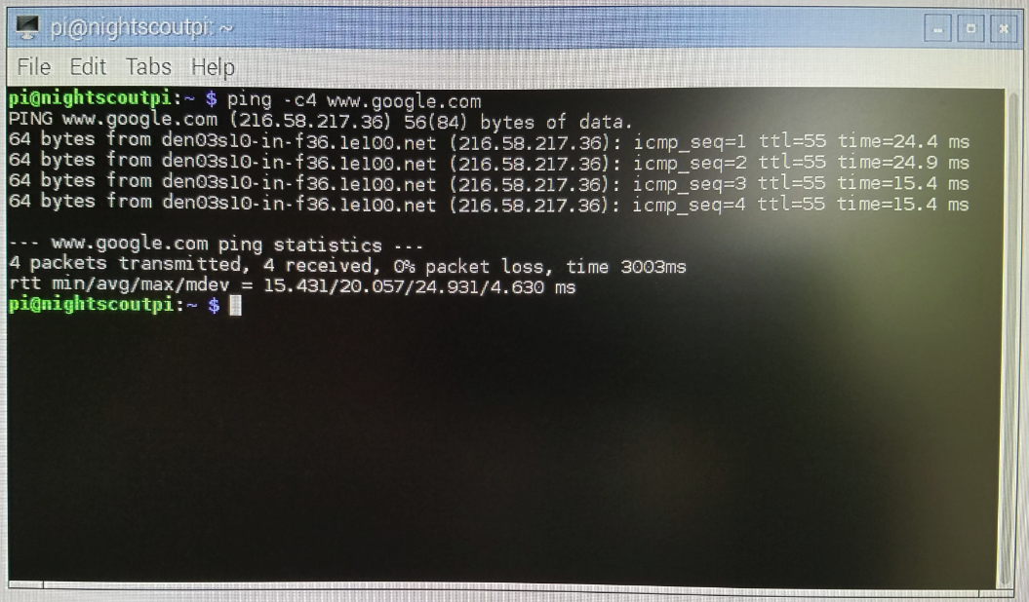

* Reboot (In your terminal window type “sudo reboot”) and recheck the ping results to make sure your network settings survive the reboot.
* Updating the Firmware and OS
  + - Open a terminal window and update the firmware
      * sudo rpi-update
    - Reboot
      * sudo reboot
    - After the reboot, open a terminal window and update the OS
      * sudo apt-get update
      * sudo apt-get upgrade (you will need to answer ‘Y’ at one point to continue)
      * sudo apt-get autoremove
    - Repeat the firmware and OS updates until no further updates are found
  + Download a real text editor (this step only for old engineers who are not impressed with newfangled text editors like nano and <full body shiver> emacs)
    - If you don’t know how to use the Vi editor, skip this step.
    - Install Vi Improved:
      * sudo apt-get install vim
    - Configure the system editor to be vim:
      * sudo update-alternatives –-config editor
        + select /usr/bin/vim.basic (probably option 3)
    - For the remainder of this document when you see “nano”, you can use “vim”
  + Configure auto network restart
    - It has been noted that the WiFi network on the Pi can disconnect when not in use. This will prevent that from occurring.
    - Write a bash shell script to check the network and reconnect if disconnected:
      * sudo nano /root/network_monitor.sh
      * add the following lines (you don’t have to use google, you could use the IP address of your PC as well):

#!/bin/bash

while true ; do

if ping -c 1 www.google.com | grep -q “1 received” ; then

sleep 120

else

echo “WiFi connection down. Restarting.”

ifup –force wlan0

sleep 10

fi

done

* + - * Type Control-x to save and exit
      * Allow the script to execute
        + sudo chmod+x /root/network_monitor.sh
    - Now automatically execute the command every boot
      * sudo nano /etc/rc.local
      * add the following lines above the last line (exit 0). **Do not forget the ampersand at the end of the line**!

# monitor the WiFi connection

/root/network_monitor.sh &

* + Optional Step: Download and Install Real-VNC
    - Real-VNC allows you to run your Pi without a keyboard, mouse, and monitor by using your existing PC. To do this, you install a VNC server on your Pi and a VNC viewer on your PC. I highly recommend getting this to work as it will make remote access of your device possible and easy.
    - On your Pi, download the Real-VNC package:

curl -L -o VNC.tar.gz https://www.realvnc.com/download/binary/latest/debian/arm/

* + - Unzip the downloaded file:
      * tar xvf VNC.tar.gz
      * note the names of the two files unpacked. When I did this the files were:
        + VNC-Server-5.3.2-Linux-ARM.deb
        + VNC-Viewer-5.3.2-Linux-ARM.deb
    - Install VNC Server and VNC Viewer (insert the names of the files you untarred in the previous step):
      * sudo dpkg -i *VNC-Server-…deb VNC-Viewer-…deb*
    - Get a free license to run VNC Server
      * go to <https://www.realvnc.com/purchase/activate/>
      * choose “Free license only, without premium features”
      * fill in your name, email, etc.
      * Click on “Get Key”
      * A key will be emailed to you.
    - Apply the license key
      * Once you have received the email key (which will be valid for up to 5 servers), apply the license by entering the key:
        + sudo vnclicense -add *enter your license key here*
    - Create a password for access (this can be anything; it doesn’t have to be the same password you entered for your pi login):
      * sudo vncpasswd -service and follow the prompts
    - Start the VNC Server and configure it to launch automatically:
      * sudo systemctl start vncserver-x11-serviced.service
      * sudo systemctl enable vncserver-x11-serviced.service
    - Install VNC Viewer on your PC
      * Go to <https://www.realvnc.com/download/vnc/windows/>
      * Select “windows” if your PC is windows…or choose otherwise
      * Click on Download VNC 5.3.2
      * After downloading run the downloaded file and install VNC Viewer.
      * Launch VNC Viewer and enter the static IP you assigned and click connect.

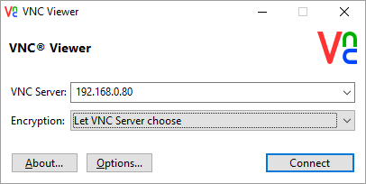

* + - * If all is working well you should receive a warning about an unencrypted connection; select “Don’t warn me about this again” and click continue.
      * A login window will then appear. Enter the VNC password you created above and click “OK”

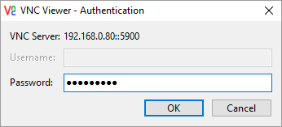

* + - * You should then see your PI desktop. You now have full control, just as though you were sitting in front of the Pi. If you desire, you can shut down your pi remove the HDMI cable to your TV/Monitor, the mouse, and keyboard, and just operate it in this mode from hereon. The display may be quite a bit smaller, but all the functionality is there after removal of the monitor, keyboard, and mouse.

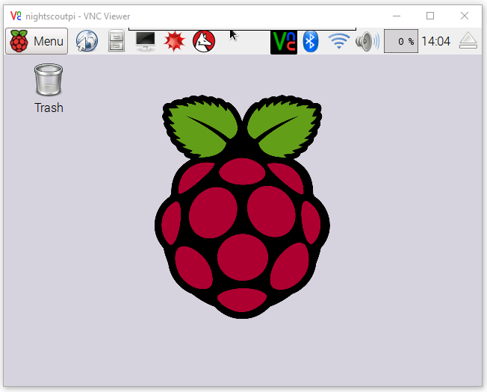

* + Your Raspberry Pi is now complete and operational. Congratulations and good luck in your Pi adventures!